**REPACKAGING LAB**

Contents

TASK 1 3

TASK 2 3

TASK 3 4

TASK 4 6

Task 4.1 6

Task 4.2 6

TASK 5 8

Task 5.1 8

Task 5.2 8

Task 5.3 9

TASK 6 12

Task 6.1 12

Task 6.2 13

Task 6.3 16

Task 6.4 17

Task 6.5 17

Task 6.6 18

# TASK 1

RepackagingLab an apk of an app provided by SEED Labs is used for for this task

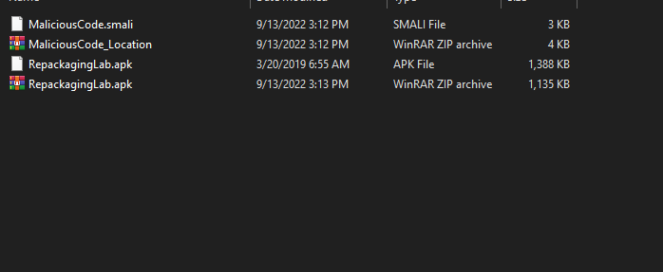

# TASK 2

Decompiling RepackagingLab.pk in Kali Linux with apktool

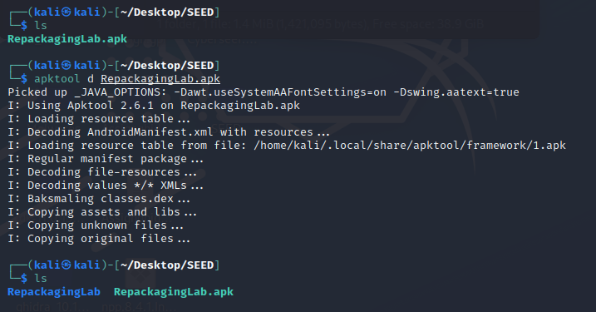

# TASK 3

Copying the Malicious Code in Application Specific Folder known as com

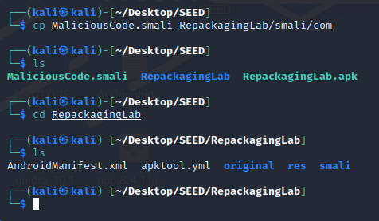

Wrote the code on line 2 to 4 to read and write contacts that’s how we can remove contacts. On line 4 we get permission for boot complete details whereas on line 14 we get boot completed broadcast message. On line 12 the Malicious File to be fetched and used is provided.

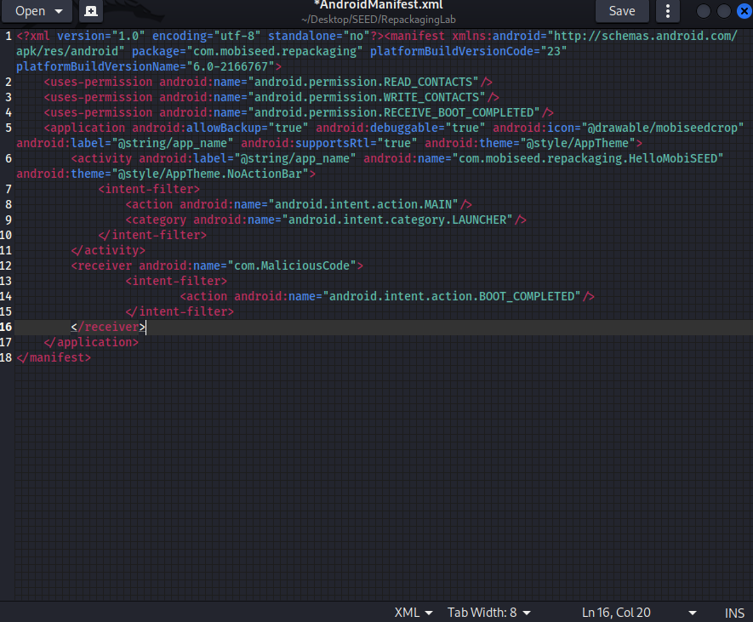

# TASK 4

## Task 4.1

Rebuilding the apk to proceed with signing.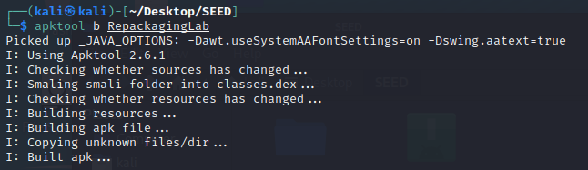

## Task 4.2

Making a Private Key for signing the apk

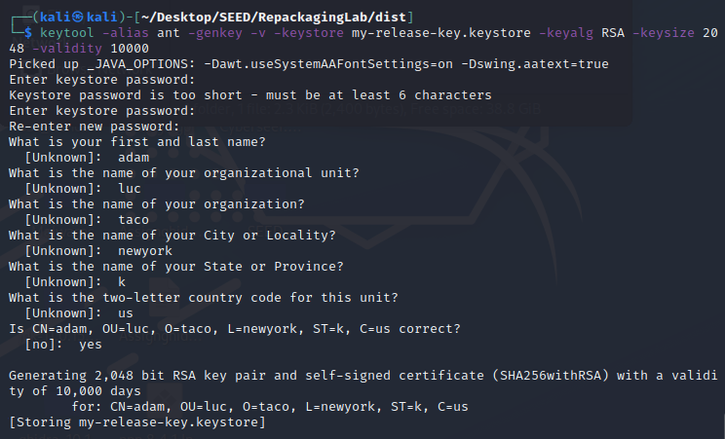

Signing apk with jarsigner

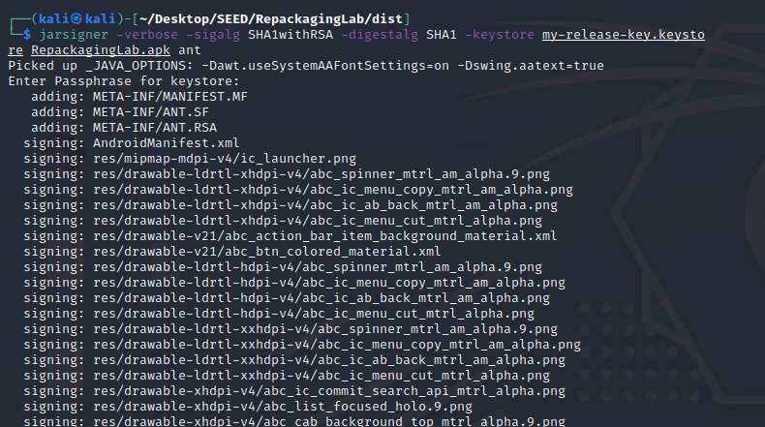

Successfully signed with jarsigner

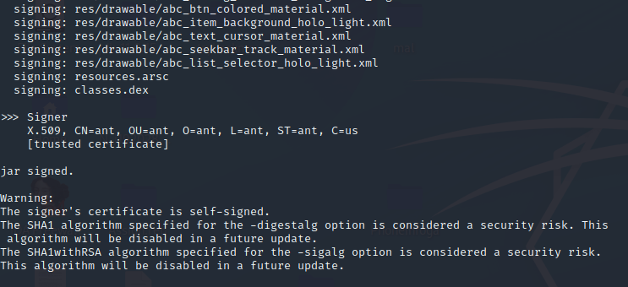

# TASK 5

## Task 5.1

Adding Some Contacts for Demonstration of Attack in Android VM

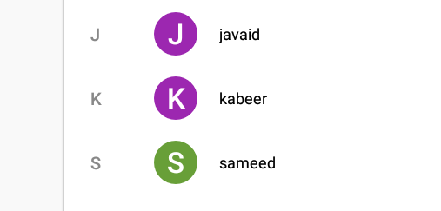

## Task 5.2

Gave Permissions to Contact App

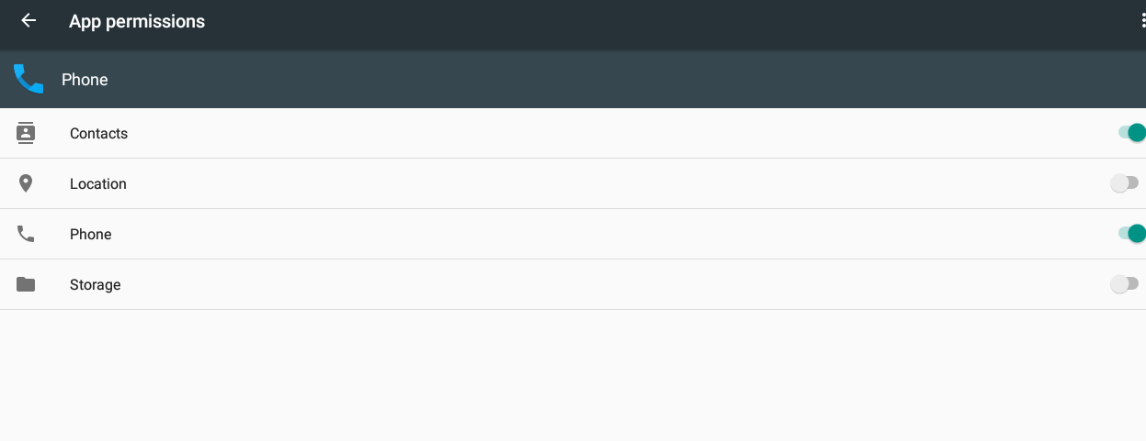

## Task 5.3

IP of Android VM fetched from it’s terminal

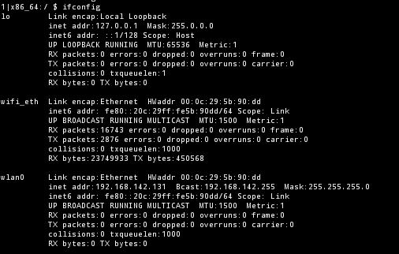

Connecting to Android VM from Attacker VM

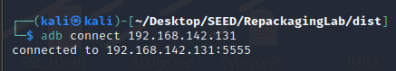

Injecting Playload and Installing it on Android VM

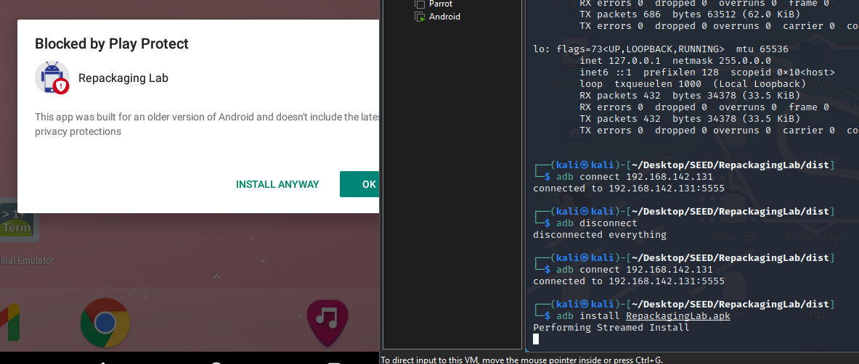

Malicious Payload Successfully Injected

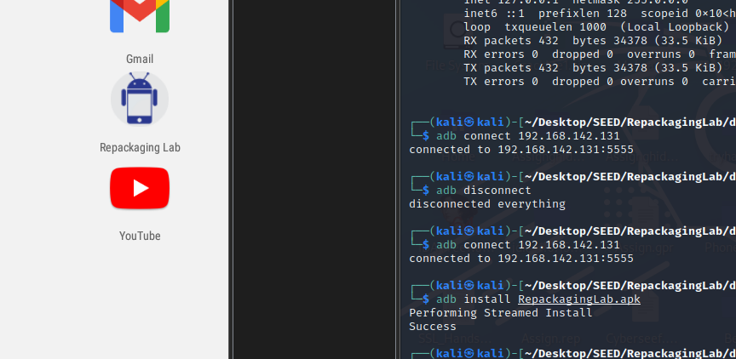

View of Repackaging Apk after installation

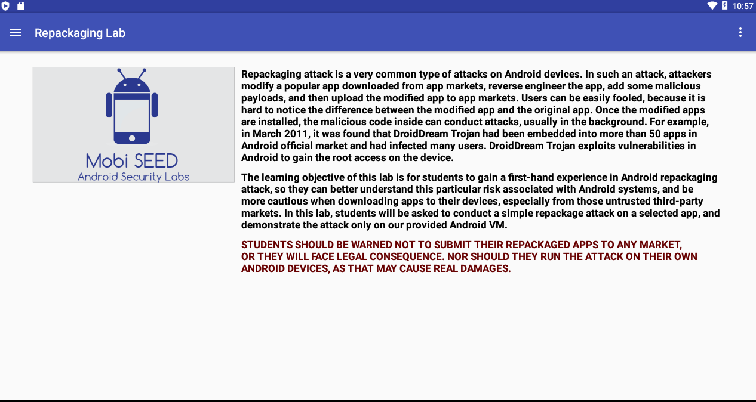

# TASK 6

## Task 6.1

To track the victim first providing victim machine with Attacker VM IP as host

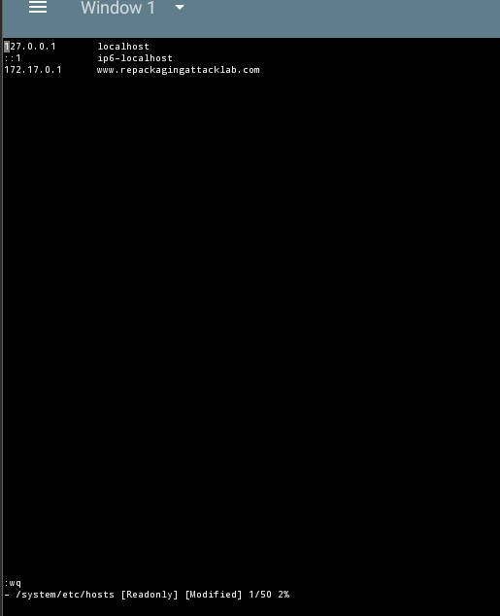

## Task 6.2

Allowing Root Access to the Terminal

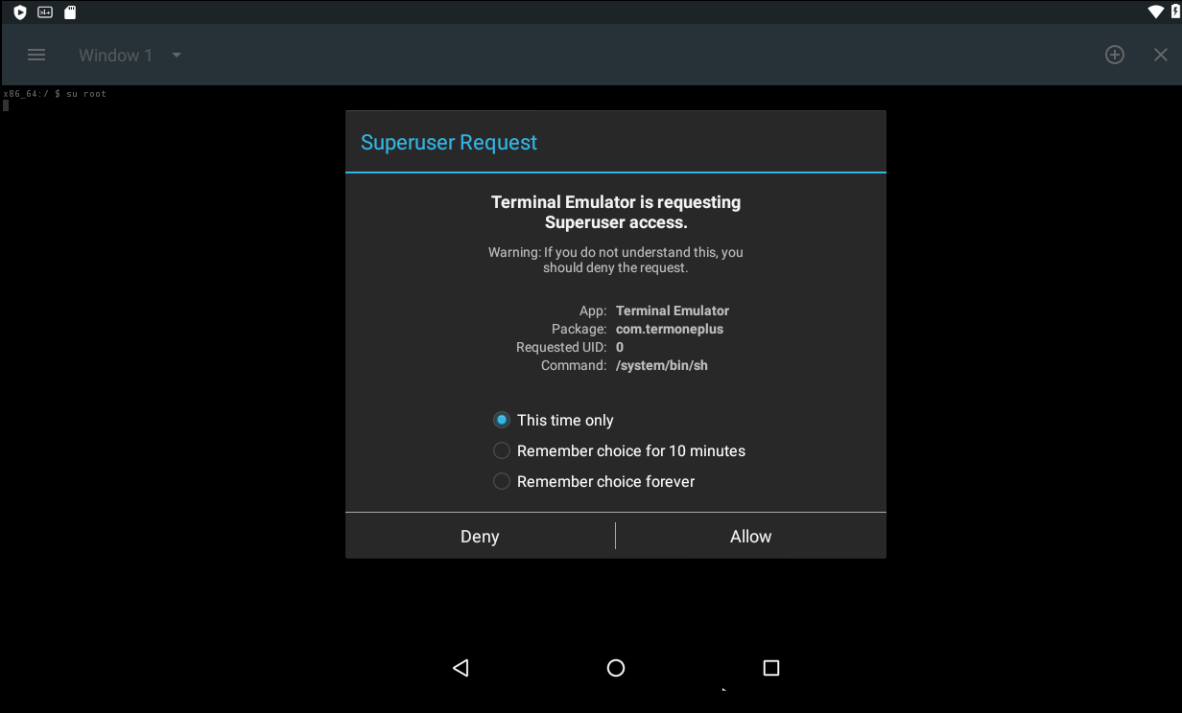

To track the victim first providing victim machine with Attacker VM IP as host



Pulling Hosts file from Android VM



Adding Victim IP in Attacker VM



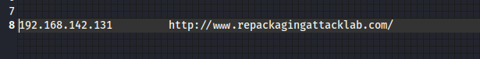



Connecting with Victim Machine



## Task 6.3

Injecting Playload and Installing it on Android VM



Malicious Payload Successfully Injected



## Task 6.4

Giving Permissions to Repackaging Lab apk to access contacts on Android VM

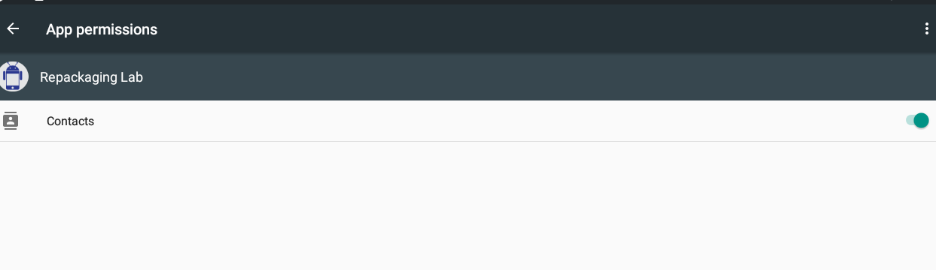

## Task 6.5

Restarting Android VM to initiate Repackaging Attack

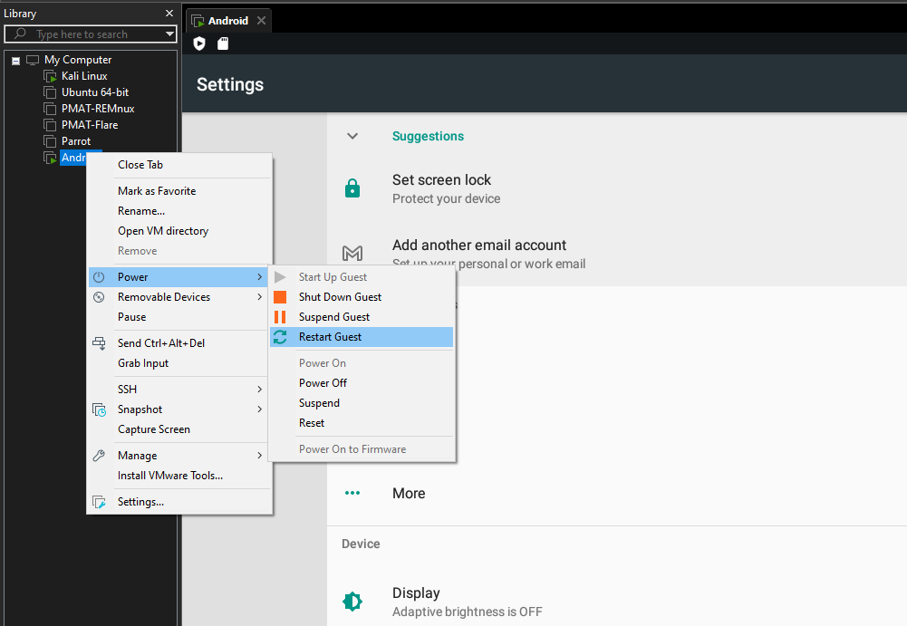

## Task 6.6

End Result Victim Lost Contacts

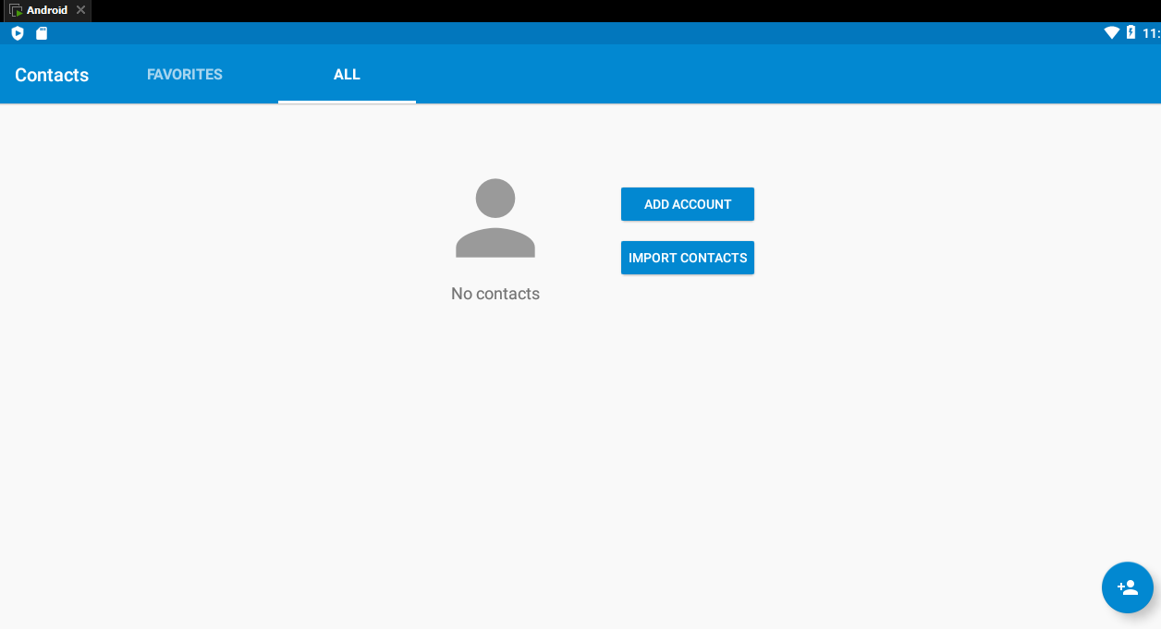

Attack can be Tracked via this link on Attacker VM but due to internet issues the working screenshot couldn’t be taken

